## Selenium RC & WebDriver

# Homework

Go to <http://test.telerikacademy.com/SoftwareAcademy/Candidate> and log in with

user: qaacademy2013 and pass: qastudent. Record a test to apply for Software Academy. Fill the form as shown below, leave e-mail blank. Verify that a message about missing e-mail appears.

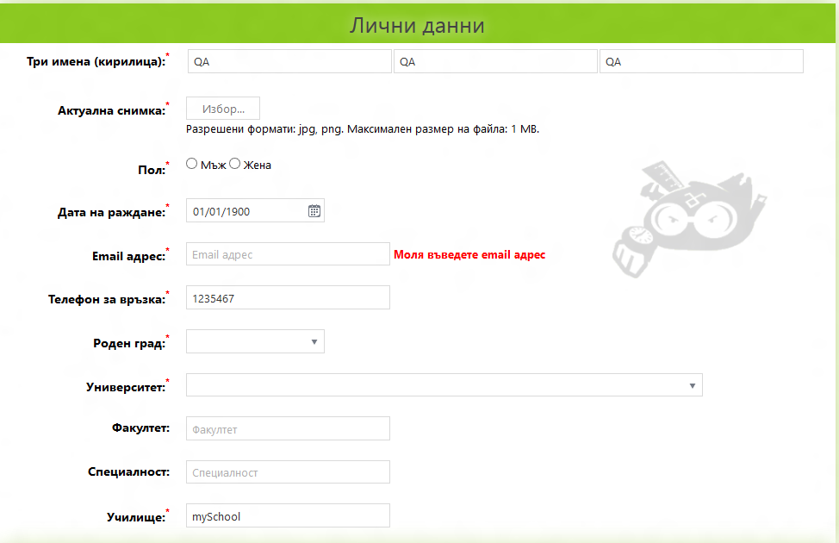

Now fill in an e-mail using JavaScript function, use unique e-mail every time. Verify the message isn’t present anymore.

## Selenium RC

Create bat files that run your test from task 1. Use different user profiles and set timeout for the different runs. Generate a unique name for result file(s) based on date-time.

## Selenium Web Driver

Convert the test from task 1 to C# and test if the backend e-mail validation works properly. For that you’ll have to disable JavaScript in your test and then start the registration. Run the test a couple of times to verify that it works correctly. Think of an appropriate way to replace your JavaScript functionality. Use different user profiles and run the test with different browsers. You can try to delete a login cookie.